**Description of a Mobile**

**Device Clip Stand**

Submitted by: Daniel Nedrow

Submitted to: Professor David Wilson

EGR 3350

Date: May 24, 2018

**Introduction**

A *mobile device clip stand* is a smart phone accessory that erects a phone into an upright position. The stand is a portable device that clips onto a phone’s top and bottom edges. Depending on the placement of the feet, the phone stands upright for vertical or horizontal viewing.

The mobile device clip stand looks like a medium household clip with curved hands at the end. A spring attaches a symmetrical pair of feet, legs, and hands. The feet, legs, and hands are made of smooth, shiny black plastic with added texture in the feet and hands. The silver-colored, metal spring rests in the joint which connects the symmetric clip stand at its feet.

The clip consists of the following parts: the feet, the spring, the legs, and the hands.

**Discussion**

For this discussion, refer to Photo 1.1 for the appearance of the clip.

***Feet***

The *feet* are a symmetric pair of plastic parts that serve as the base of the stand. The feet provide two functions. First, they can be oriented to allow for a phone to be viewed in either the vertical or horizontal position; and second, they serve as finger grips for prying open the clip. The feet are tongue-shaped, shiny black plastic parts; each foot is 2.5 centimeters long, 1.7 centimeters wide, and 0.3 centimeters thick. The top of each foot has eight grooves which provide texture for gripping. The feet jut out from each other at a 120-degree angle. At the base of the legs, the bottom of the feet contains a joint which holds the spring.

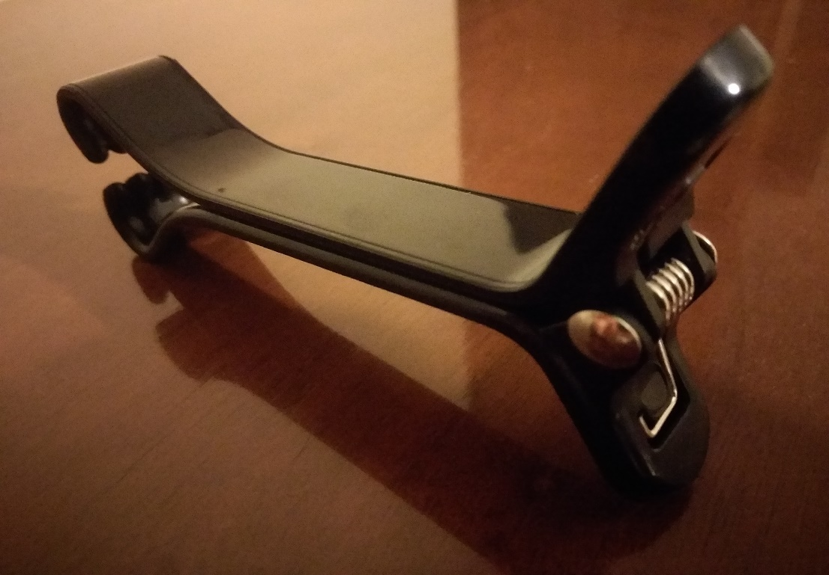

**Photo 1.1**

A view of the clip stand.

***Spring***

The *spring* is a hardware device that holds the legs tightly together. The spring serves as a hinge to pry open the legs of the clip stand while maintaining firm pressure to close the clip hands around the phone. The spring is made of smooth, shiny silver steel. The coil consists of five rings which wrap around a central cylinder, and the cylinder is locked into the joint by a pair of flat discs on both ends. The coil extends from both of its ends and straightens out into the base of each foot, where it locks into place to provide the pressure needed to keep the clip tight. The central cylinder is 1.6 centimeters long, and the discs have a diameter of 0.6 centimeters. Each ring is 0.1 centimeters wide, giving the coil a length around the cylinder of 0.5 centimeters. The coil extends 1.4 centimeters into the base of each foot, before turning at a right angle and extending another 0.8 centimeters, and finally 0.3 centimeters at another right angle. The spring attaches the feet at the base of the legs.

***Legs***

The *legs* are a symmetric pair of plastic parts which connect the feet to the hands. When opened, they provide the distance needed between the hands to wrap around a large smart phone. The smooth, shiny black plastic legs are each shaped like a tongue depressor. Each leg is 6 centimeters long, 1.7 centimeters wide, and 0.2 centimeters thick. The bottom of each leg bends outward at a 120-degree angle to become a foot. The top of the legs curve outward to become the hands.

***Hands***

The *hands* are a symmetric pair of plastic parts that grip around the edges of a smartphone. The hands hold a phone tightly in place so that it won’t fall out of the clip stand. Again, the material is smooth, shiny black plastic. The hands curve outward from the legs of the stand, and then begin to curve inward to form a grip. Thus, the hands together form a heart shape, with a gap between the end of the left and right hand. There are four textured fingers (shallow grooves in the plastic) at the end of each hand. Ignoring the curvature, the hands extend outward another 3.7 centimeters from the legs. However, the entire curved length of each hand is 5 centimeters. The textured fingers comprise 1 centimeter of this length. As with the legs, the hands are 1.7 centimeters wide and 0.2 centimeters thick.

**Conclusion**

The mobile device clip stand is a smart phone accessory which erects a phone into an upright position. The stand consists of four parts: the feet, which serve as finger grips and a base for vertical or horizontal viewing; the spring, which serves as a hinge to pry the legs open while keeping the hands tight around the phone; the legs, which connect the feet to the hands; and the hands, which grip the phone tightly in place. Together, these parts allow for convenient viewing of a smart phone screen, without the need to hold the phone in one’s hand.